Predatory, Rogue, or Bandit Towing occurs when less-than-scrupulous towing companies use deceptive or coercive practices to take advantage of motorists in stressful and vulnerable situations. From the beginning of 2022 to the end of 2024, NICB has seen an 89% increase nationwide in predatory towing claims. These claims come from big cities, small cities, suburbs, and rural areas alike.
NICB’s new public service announcement on predatory towing helps to remind your community that if they’re involved in a crash or their vehicle is towed unexpectedly, they should think twice before handing over keys, verify the tow company before agreeing to any service, and know where the tow company is taking the vehicle.
We appreciate your support with donated airtime to share this message.
Catherine Riedel
Director, Public Affairs
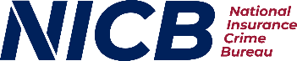
630-280-8949

